CS3350 Assignment 1 Due: Sunday, 09/03 11:59 p.m.

You are given the source files for ArrayBag ADT. You can download the source codes from Canvas in “Assignment 1”, and open the project by opening the solution file using visual studio. The source files contain ArrayBag.h (header file), ArrayBag.cpp(contains the implementation of all methods), and assignment1.cpp. **Please take a look of all the files before starting your task.**

You are required to create a new ADT named 'MyBag' that inherits from the 'ArrayBag' implementation. This new data type adds a single public method:

bool removeAll(const ItemType& anEntry)

This method will remove **all** instances of **anEntry** from the bag. If the item anEntry does not exist in the bag, it returns false - otherwise it returns true.

**Important note**: **Do not add or delete any files in the provided project.** The Visual Studio interface should be consistent with the figure below. When editing the Mybag.cpp file, simply locate the file in the project folder and double click on it to open: Do not drag the file into the Visual Studio Project.

**Your Tasks:**

1. Define the header for this new type in the file MyBag.h.
2. Write the implementation of the removeall() method in the file MyBag.cpp.MyBag.cpp is already in the folder of “Assignment 1” so you do not need to create it.
3. In Assignment 1.cpp, write your codes inside the “bagTester” function and your program should:

a. ask user to add string-type items into the bag.

b. loop until the users enters “stop” to finish adding items to the bag.

c. display current size and items in the bag.

d. ask for a string to remove and call removeAll() with that string as an argument.

e. display current size and items in the bag.

(Hint: To call the remove() method from a derived class, e.g. Mybag class, you can do “this->remove(anEntry).”)

A sample of output is as follows: 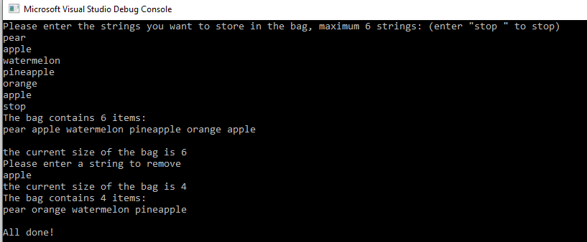

**Zip & Submit**

**Zip** your top level solution folder, name it **Firsttname_CS3350_Assignment1** and submit it to the Assignment1 link on Canvas. Make sure you upload the complete project, i.e. your entire project can be opened by the .sln file.

**Grading Rubric**

_______ (4) proper documentation/comments where appropriate

_______ (4) implementation of MyBag.h

_______ (4) implementation of MyBag.cpp

_______ (8) implementation of bagTester Function (user input, remove entries, display items, and display current size.)